**CONVERSION OF ALL FORMS OF CURRENCIES, WEIGHTS, HEIGHTS AND TEMPERATURES**

ADYA ABHIPSA PANDA

(B.Tech 1st Year, Department of Computer Science and Engineering,

Siksha O’ Anusandhan, Deemed to be University, Bhubaneswar, Odisha, India)

adyapanda02@gmail.com

**Abstract –**

The ideation of this paper is to give our user an option to choose a type of conversion of his own choice and continue conversions as many times the user wants. It is basically a java program that allows the user to convert the existing data into any other type he/she wants (provided the conversion is feasible). This free conversion calculator is designed for specific conversions i.e. currency, height, weight and temperature and is easy to use so that anyone can perform his required conversion actions.

**KEYWORDS-**

Conversion; Calculator; Java code; user choice

**INTRODUCTION-**

In the past, many systems of measurement were defined on a local level, and could be based on factors as arbitrary as the length of a king's thumb. While this may work on a local level, when considering trade, as well as science, having systems of units based on units that others may not be able to relate to or understand makes interaction difficult. As such, the development of more universal and consistent systems developed over time.

The International System of Units (SI) is the standard metric system that is currently used, and consists of seven SI base units of length, mass, time, temperature, electric current, luminous intensity, and amount of substance. Although SI is used almost universally in science (including in the US), some countries such as the United States still use their own system of units. As such, many unit converters including this Conversion Calculator exist, and will continue to do so to ensure that people globally are able to communicate different measurements effectively.

It proves invaluable time and again when an exact conversion from one set of engineering units to another is required quickly. We can simply run this code on our Java IDE (originally the program was run in Eclipse IDE) and give our desired choice as input and the program will process the given data accordingly.

For example-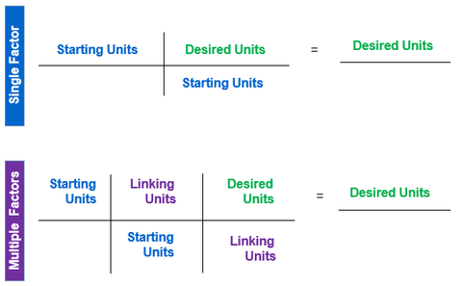

**TECHNIQUES-**

In this busy world where every user wants his tasks to be completed with a fraction of sections without any hassle, this programming unit conversion tool comes really handy. Some techniques used in the conversion of units are as follows –

Suppose the entered data is d.

1. **Currency Conversions-**

* "Dollars converted to Rupees+(d*74.274977)
* Pounds converted to Rupees +(d*102.60852)
* Malaysian Ringgit converted to Rupees +(d*17.51)
* Japanese Yen converted to Rupees+(d*0.68)

1. **Weight Conversion-**

* Kilograms equivalent Grams is +(d*1000)
* Kilograms equivalent Ton is +(d*0.001)
* Kilograms equivalent to lbs +(d*2.205)
* Kilograms converted to Stone +(d*0.157473)

1. **Height Conversion-**

* Metres converted to Centimetres is +(d*100)
* Metres converted to Inches is +(d*39.3701)
* Metres converted to Foot +(d*3.28084)
* Metres converted to Miles +(d*0.000621371)

1. **Temperature Conversion-**

* Celsius equivalent Fahrenheit is "+(d*1.8)+32)
* Celsius equivalent Kelvin is +(d+273.15)
* Celsius equivalent Rankine is "++(d*1.8)+491.67)
* Fahrenheit equivalent Kelvin is "+((d-32)*0.56)+273.15)

**DISCUSSION-**

What and why?

SI units of conversion help us to convert one unit into another in a system of like physical quantities. There is a wide range of units and hence their conversions. Using this java code program, one can easily perform unit conversions in a click which saves time of the user and gives accurate results.

**ADVANTAGES AND LIMITATIONS –**

**Advantages-**

* Easy to use
* Faster output
* Maintained accuracy

**Limitations-**

* Since this is a coding program, the user will not be able to modify or improvise the code in case needed.
* Limited conversions are included in the program.
* Expects correct output from user, else program will display error message.

**CONCLUSION-**

It can be concluded that in this world of change, converting units plays an important role in our daily lives. Whether we notice or not, we continuously convert things from one to another as per our needs.

Hence we need a tool which helps us execute correct conversions without having to perform the calculations manually. This program comes handy while performing conversions related to currency, weights, heights and temperatures. It provides a quick solution to the user required conversion using JAVA and certain pre-defined mathematical calculations.

**REFERENCES –**

* [**https://www.calculator.net/conversion-calculator.html**](https://www.calculator.net/conversion-calculator.html)
* [**https://www.physlink.com/reference/unitconversion.cfm**](https://www.physlink.com/reference/unitconversion.cfm)
* [**https://www.unitconverters.net/**](https://www.unitconverters.net/)